15.1.1: Car Dealership Sales System

ALGORITHM
- START
- DEFINE a base class Car:
  - METHOD __init__(self, brand, price, model, color):
■ Initialize the attributes self.brand, self.price, self.model, and self.color.
○ METHOD display_details(self):
■ Print the attributes of the car.
- DEFINE derived classes Car1 and Car2 inheriting from Car:
  - OVERRIDE the display_details(self) method in both classes to print car information (brand, price, model, and color) each on a separate line.
- MAIN PROGRAM:
  - READ the input for Car1 (brand, price, model, color) from a single line.
○ READ the input for Car2 (brand, price, model, color) from a second line.
○ INSTANTIATE objects for Car1 and Car2 with the provided inputs.
○ CALL the display_details() method for the Car1 instance.
○ CALL the display_details() method for the Car2 instance.
- END

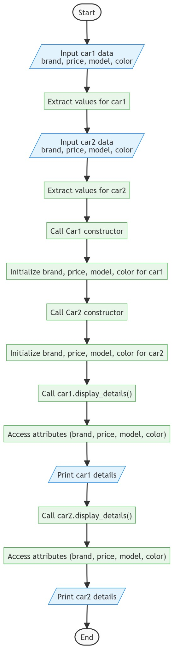
FLOWCHART

